Activity-1

Activity-2

Activity-3

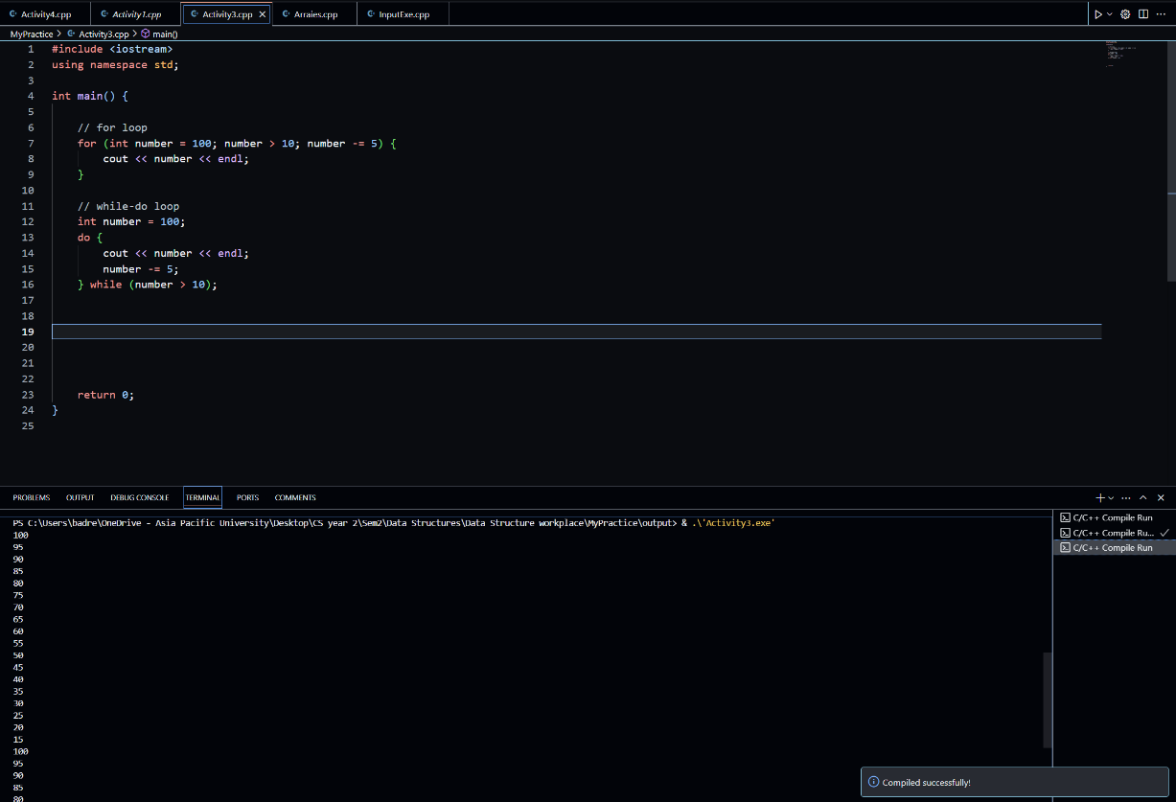

Activity-4

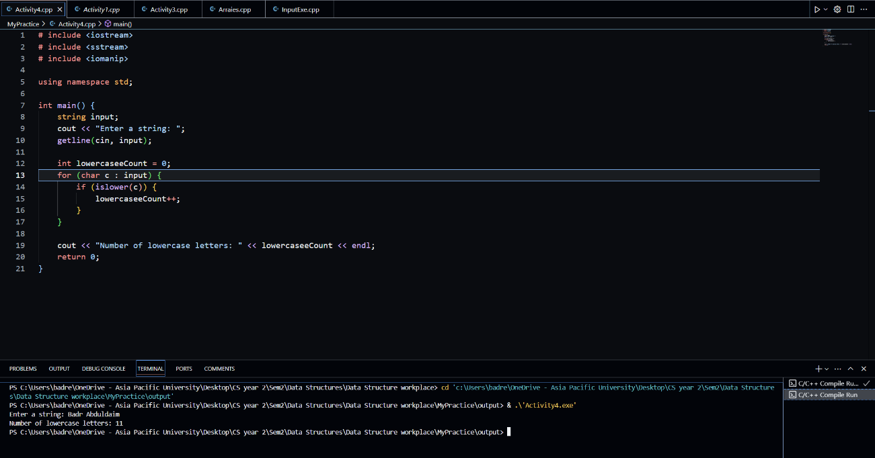

Activity-5

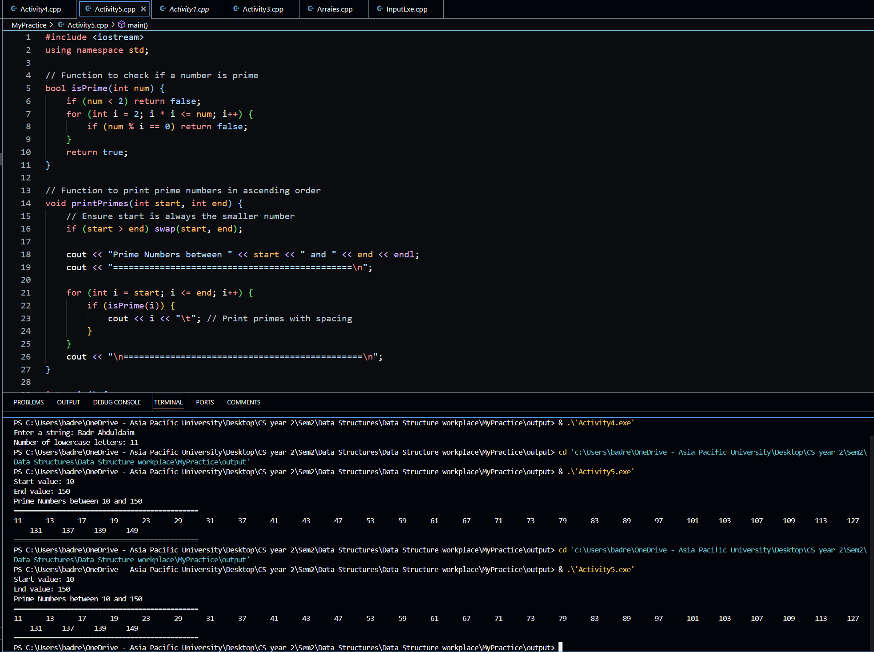

Lab1(PartA)

Part-B

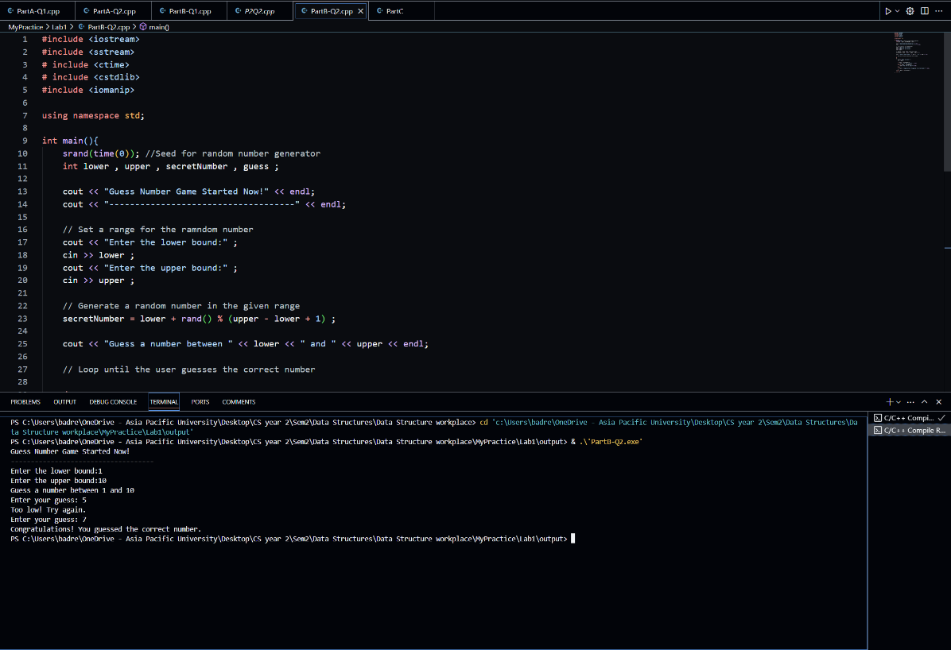

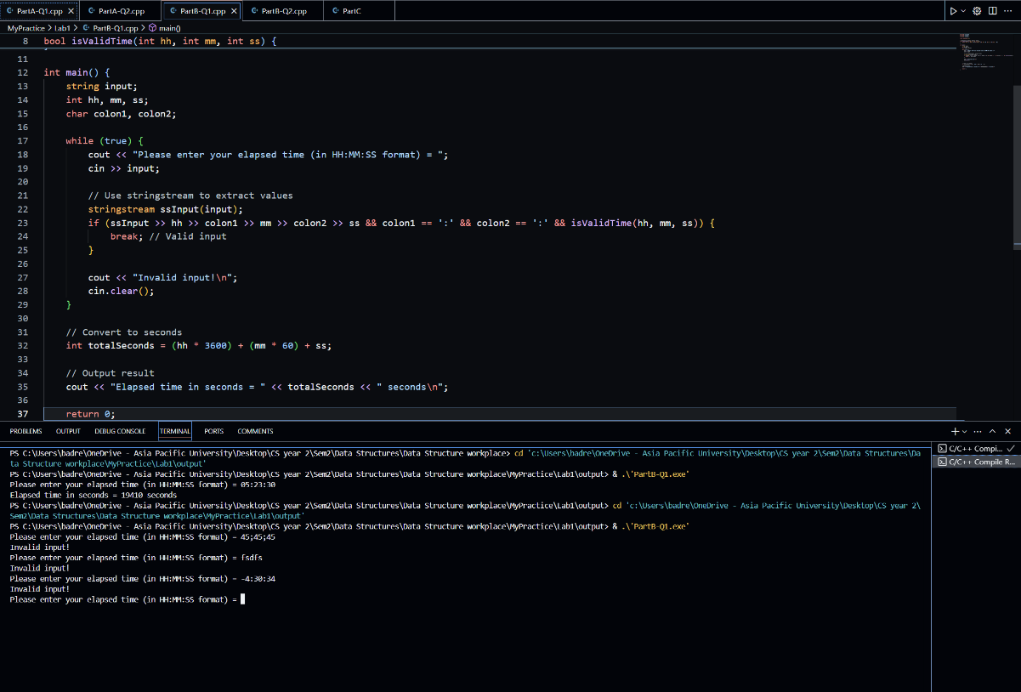

Part-C

